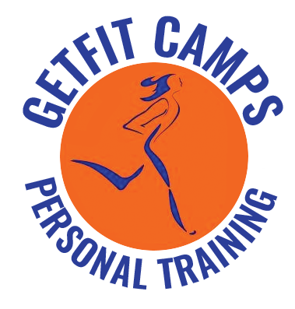

CUE QUEST - Physical Wellness
Workshop Booklet

Looking for more workouts or more information on GetFit Camps and our trainers?

Check out our website:
www.getfitalberta.ca

or Like our Facebook page:
www.facebook.com/GetFitCampsLacombe

or Contact Candace Sayler
Phone: 403-505-8699 or Cortney
Phone: 403-302-8611
Email: cmsayler@telus.net

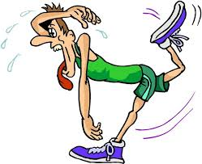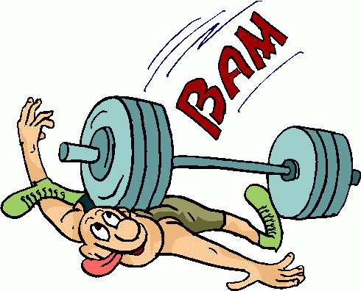

Cardiovascular Activity

Cardio exercise is any exercise that raises your heart rate. Face it our bodies were made to move. And we all know that to keep our muscles in shape we need move them. This movement makes them stronger and stronger muscles make for a more efficient and healthy body. Your heart is a muscle. Therefore working it makes it stronger. A stronger cardio-vascular system means more capillaries delivering more oxygen to cells in your muscles. This enables your cells to burn more fat during both exercise and inactivity.
Cardio exercise uses large muscle movement over a sustained period of time keeping your heart rate to at least 50% of its maximum level. To obtain your Target Heart Rate check out our calculator at www.healtstatus.com - calculators - Target Heart Rate. Sample cardio workouts would be walking, running, bike riding, and swimming, rowing and aerobic workouts. Workouts should cause moderate sweating. If you can’t finish a sentence while doing your workout you are going at it too hard. If you are having no trouble talking step it up. You need a minimum of 20 minutes of continued elevated pulse to get the best results at least 3 times a week. The American College of Sports Medicine recommends 30 minutes of moderate intensity physical activity most days of the week. Cardio exercises will burn fat. Weight loss comes from burning more calories than you take in. Even when you see no specific weight loss you are getting great benefits from a cardio workout. Benefits: Weight Loss Stronger Heart and Lungs Increased Bone Density Reduces Stress Better Sleep More Energy Reduces the Risk of Heart Disease Teaches the Heart to Work More Efficiently Strengthens Heart & Lungs Increased Energy Levels for a More Active Lifestyle Reduction in Mood Swings & Depression In order to feel good now and in the future you need cardio exercise. It will not create 6 pack abs or tone problem areas but it will make your body more efficient in your day to day living.

Conditioning:
Exercise and practice to build the body up for either improved normal performance, as in physical therapy, or in preparation for sports performance. 2) A method of educating involving repetitive activities to influence behavior.
The balance and strength of the tissues in your body rely largely on the amount of exercise you perform each week. This exercise increases the fitness of the tissues in your body, whether through building muscles, burning fat or increasing the efficiency of your organs.
- Muscle Conditioning (Strength Training): One of the main aspects of a body-conditioning exercise is how it affects your muscle tissues. All conditioning exercises include some form of movement or resistance training. As this resistance is placed on the muscles, microscopic tears develop in the tissues, activating cells that build up the muscle tissues and conditioning the muscle group for similar exercise movements in the future.
- Heart Conditioning (Cardiovascular Training): Not only are skeletal muscles conditioned by conditioning exercises, but the heart muscle also is conditioned. When you exercise regularly, the need for energy in your body increases. For new energy to be created, plenty of oxygen needs to be available in your bloodstream. To transport this oxygen, your heart beats faster, speeding up the delivery of both oxygen and nutrients to your cells. Like any muscle, the harder the heart muscle works, the stronger it becomes. This increase in strength translates to the heart not having to work as hard to pump blood throughout your body.
- Lung Conditioning (V02 Max): Conditioning exercises also help strengthen your lungs. In order to supply the bloodstream with the necessary oxygen needed to create energy, the lungs must inhale and exhale enough oxygen to sustain you during exercise. When you make conditioning exercises a habit, this increases your respiratory rate and helps increase the amount of time you can exert energy without running out of breath. Conditioning exercises also increase the overall health and strength of your lungs. Sprints are particularly good for lung conditioning.

Agility:
Agility or nimbleness is the ability to change the body's position efficiently, and requires the integration of isolated movement skills using a combination of balance, coordination, speed, reflexes, strength, and endurance. Agility is the ability to change the direction of the body in an efficient and effective manner and to achieve this requires a combination of
- Balance – the ability to maintain equilibrium when stationary or moving (i.e. not to fall over) through the coordinated actions of our sensory functions (eyes, ears and the proprioceptive organs in our joints);
- Static Balance – the ability to retain the centre of mass above the base of support in a stationary position;
- Dynamic Balance – the ability to maintain balance with body movement;
- Speed - the ability to move all or part of the body quickly;
- Strength - the ability of a muscle or muscle group to overcome a resistance; and lastly,
- Coordination – the ability to control the movement of the body in co-operation with the body's sensory functions (e.g., in catching a ball [ball, hand, and eye coordination]).

In sports, agility is often defined in terms of an individual sport, due to it being an integration of many components each used differently (specific to all of sorts of different sports). Sheppard and Young (2006) defined agility as a "rapid whole body movement with change of velocity or direction in response to a stimulus".

Agility and Conditioning Exercises:
- Running Sprints: (make sure hamstrings are good a warm)
10 sprints, 40 meters long with quick feet carioca back to starting point, alternate carioca direction after each sprint. Try to rest no more than 1-2 minutes between sprints. Sprint hard (like a bear is chasing you . . .)
- Hill Sprints:
Make sure to warm up with little jog and some dynamic leg swings and striders. Set timer for either 10 or 15 minutes. You will then sprint all out to top of hill. Walk down and try not to rest for more than 1-2 minutes between sprints. You will work on how many sprint you can do in the 10 or 15 minutes.
(Hill in behind College Heights Christian School and CUC gym is awesome.)

- Agility Circuit:
3 rounds, minimal rest
20 metre sprint with backward run to starting point
20 metre side shuffle (there/back) – can add 180 and 360 turns
20 metre quick feet carioca drill
20 metre forward pivot drill around pylons
20 metre quick feet forward then quick feet back – can add 180 and 360 turns
20 metre high knee run with butt kick back
**do one sprint/agility drill a week
- Ladder Drills:
http://www.youtube.com/watch?v=S7NuVcxhzDI
https://www.youtube.com/watch?v=t26CIBKRKWE
**Pick about 6 foot drills and do each one 3 times. Keep foot speed workout to about 5-10 min tops. Do once a week.
Examples of Foot Drills:
  - High knees run
  - Side Shuffle w/stop
  - Hopscotch
  - High knee skip
  - Jumping jacks
  - Side ladder foot flutter
  - 3 sets of each exercise

HIIT – High Intensity Interval Training (INTENSE-training):
HIIT is a form of cardio performed at such an intense level that your body will spend the rest of the day expending energy to recover. This is commonly referred to as EPOC (excess post-exercise oxygen consumption) and it means that you consume a great deal more oxygen recovering from the exercise bout than you would have if you'd just done a steady-state workout.
This means that you will be burning up to nine times more fat while sitting on the couch later that night than you would have if you'd spent an hour on the treadmill at a moderate pace. You will need to push yourself out of that comfort zone you have gotten used to and really challenge yourself. You will spend less than half the time you usually do on those machines and get much leaner in the process.
HIIT training has a number of benefits in addition to the reduction in training time. First of all, this type of training is far superior to steady-state exercises when it comes to increasing your VO2 max, which is the maximum amount of oxygen you can uptake during exercise.
Secondly, when you perform long-duration, moderate-intensity exercise, you can actually put yourself in a catabolic state in which you will start losing muscle mass. The reason is that there are two types of muscle fibers in your body: fast twitch and slow twitch. Slow twitch fibers are more compatible with endurance training (such as a steady-state one-hour run), whereas fast twitch fibers are more compatible with short, intense bouts of exercise (such as weightlifting or sprinting).
When we train in one of these modes, our muscle tissue has a tendency to take on the appropriate properties. As an illustration, imagine a marathon runner and a sprinter. The sprinter is composed of fast twitch muscles and carries a great deal more muscle mass, whereas the marathoner has a lot of thin, slow twitch muscle fibers so that his body is as light as possible to transport across those great distances.
Interval Cardio Training:
- Ratios for training:
  - 30sec/30sec
  - 30 sec/60 sec
  - 1 min/1 min
  - 60 sec/90 sec
  - 2 min/2 min
- Do a warm up of 3-5 min
- Interval training can be done for 20-40 mins
- Cool down 3-5 min
- Sprint – needs to be HARD – 85% of max
- Recovery – needs to be total recovery – EASY

Examples:
- Treadmill: run as fast as you can for 60 sec. and easy walk for 60 sec – repeat for 10-20 cycles
- Bike: pedal as fast as can (over 100 RPM) at as hard of tension as can (7-10) sprint for and then pedal at 65 ish RPM at 2 or 3 tension for recovery.
- Elliptical: sprint as fast as you can move (120+ SPM) at 8-12 tension; recovery 3-4 tension at 85 ish SPM
- Rowing – always keep tension at 10 – SPM will just change – sprint: try to hold 40+ ish SPM and recovery 25 ish SPM

Cardiovascular Requirements:
According to ACSM - You need a minimum of 20 minutes of continued elevated pulse (50% or higher) to get the best results at least 3 times (more is recommended) a week.
- Swimming
- Biking
- Walking
- Running
- Rowing
- Elliptical
- Stair climber

Strength Training

Strength Defined:
- Strength training is a type of physical exercise specializing in the use of resistance to induce muscular contraction which builds the strength, anaerobic endurance, and size of skeletal muscles.
- Strength training is a method of improving muscular strength by gradually increasing the ability to resist force through the use of free weights, machines, or the person's own body weight. Strength training sessions are designed to impose increasingly greater resistance, which in turn stimulates development of muscle strength to meet the added demand.
- Strength training is a period of training in which high levels of volume (weight resistance) with minimal rest periods resulting in muscular hypertrophy.

Strength, power and muscular endurance are fitness components with many things in common. They require the application of muscular force to overcome resistance while in motion; they involve muscular contraction of a specific muscle or muscle group; and they are measurable components of fitness. Training programs can improve these fitness components.
- Strength: Muscular strength is the ability of a muscle or muscle group to exert force to overcome the most resistance in one effort. Strength can be measured based on the amount of weight lifted. Upper-body and lower-body strength are measured separately. Strength tests include the bench press for upper body, the squat for lower body and the deadlift for lower back and leg assessments. Relative strength is based on a ratio of weight lifted to body weight. For example, if two people lifted the same weight, the person who weighs less has greater relative strength.
- Power: Power is defined as the amount of work performed per unit of time. Power is an element of skill-related fitness that is needed to excel in athletic performance. Increased strength does not always translate into increased power. For example, a strong upper body lifts a high amount of weight. However a strong upper body does not always have the ability to throw a shot put very far if enough speed cannot be generated.
- Muscular Endurance: Muscular endurance is the ability of a muscle or muscle group to exert force to overcome a resistance many times. Often the resistance is the body itself. The measurement of muscular endurance is based on the number of repetitions performed. Muscular endurance is specific to the assessment. The ability to perform upper-body exercises many times is separate from the ability to perform lower-body or abdominal exercises many times. Muscular endurance tests include push-ups, pull-ups and dips for the upper body, sit-ups for the abdominals and plank for core. Lower-body endurance can be assessed with squats.

Training:
Training is specific to fitness or skill goals. Strength training is based on progressive resistance exercises. Workouts consist of higher weights and lower repetitions. You should perform three to four exercises for each muscle group with three to four sets of six to eight repetitions each. Longer rest periods between sets allow for increased strength for the next set. Endurance training is based on progressive repetition exercises. Workouts consist of lower weights and higher repetitions. Perform three to four exercises for each muscle group with three to four sets of 10 to 12 repetitions each. Shorter rest periods between sets increase fatigue levels for the next set. This type of training will further improve endurance levels. Power training is similar to strength training. In addition, explosive movements geared to specific skill development should be added to training programs.

Considerations:
Consult a personal trainer to get help assessing your strength, power and muscular endurance. A trainer can also help you set reasonable goals and provide you with a training plan for reaching them. Always consult your healthcare provider before beginning a new exercise program. Your doctor or other medical provider can assess your general health and tell you if the program is right for you.
GetFit Camp Offer
Book in one hour group personal training sessions for $10-$15 each. Four people per session = $15 each. Six people per sessions = $10 each. Get fit testing and training, nutritional counselling, and sport specific training . . . you will work with one of our trainers and we will help you meet your goals.

Other Resources:
www.exrx.net
www.bodybuilding.com

Strength Training Workout
Warm Up:
Jog, side shuffle, bum kickers, squats, pulse squats with jump, mountain climbers, push ups
Tabata with Partners: 20 Seconds Work : 10 Seconds Rest
Partner A | Partner B
Lateral lunge with med ball curl | Split Jump Lunges
Log Leaps | Push Ups
Squats | Mountain Climbers

Fast Feet Drill:
Left, right, forward, back, jump up, down, sit

TRX & Core

What is Core?
The core, contrary to popular belief, is not just your abdominal muscles. Basically if you were to remove your head, your legs and your arms from your body, that is your core. The term core is used to represent the group of muscles that stabilize and move the spine. The spine needs to be able to safely extend, flex both forward and to the sides as well as rotate. The core has two layers, a deep layer and a superficial layer. The deep layer of core muscles includes, but is not limited to the transverse abdominis, pelvic floor muscles, diaphragm, and multifidus. The superficial layer includes the internal and external obliques, rectus abdominis and latissimus dorsi. These are some of the main core muscles, some of the other muscles related to the core are the gluteus maximus and trapezius.
The core is not just required for heavy lifting, it also required for functional movements. These functional movements are highly dependent on the core, those movements can include sitting, walking, standing upright, picking up objects, and so much more. The lack of core development can result in a predisposition to the occurrence of injury.
So all of that said, you core should be engaged no matter what it is you are doing. This means almost every exercise could be considered some form of core exercise. There are however some exercises that are better at target specific areas of the core.

Engaging your core:
There a few different techniques to engaging the core. The technique we reviewed in the workshop was as follows; sit or stand tall with good posture. From there draw your belly button back towards your spine, and then up towards your rib cage.
Another way you can find part of your core, specifically the transverse abdominis is to start by lying on the ground, face up. Your knees should be bent, the feet should be flat on the floor. Your back be in its neutral position, meaning you should have a slight arch in the lower part of your back. Place your fingertips just to the inside of the hip bone on the lower portion of your abdomen. From there think about contracting the muscles you use to stop the flow of urine. If you practice that motion you should feel the muscles under your fingertips tighten. From there you can practice holding the transverse in contraction while you draw the belly button to the spine and up to the ribs.
It will take some practice and work to be able to recognise when your core is engaged. If engaging your core is new to you, it may take some time to build up your cores ability to be engaged for extended periods of time.

Breathing and Your Core:
We’ve all seen him, that guy in the gym, lifting crazy weights and you swear he is going to pass out any time now because he hasn’t taken a breath since he started. Many people think that in order to brace your core you need to suck in, bear down and hold your breath, when in reality you aren’t doing yourself any favors. Realistically you should be able to brace your core, without having to hold your breath. You should still be able to breath and even converse while your core is engaged.

Core Exercise:
So to recap before you start to exercise, here are some things to remember when attempting to engage and train your core;
- Posture: Good Posture = Engaged Core, Engaged Core=Good Posture. Stand tall, and don’t wear your shoulders as earrings.
- Breathing: You should be able to breath easy, avoid baring down or holding your breath.
- The core is more than just your 6-pack ab muscles.
Now for the workout, remember just because you can do 100 sit ups doesn’t mean you have a strong core. A core exercise uses the posterior chain (the back and glute muscles) and the anterior chain (abdominal muscles). Complete 10 of each exercise, 3 times through. Rest and breath between rounds.
Exercise | Sets | Reps | Cues
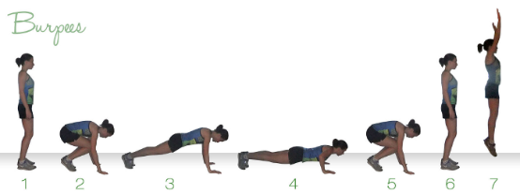  Burpees | 3 | 10 | -If jumping out is too intense, you can step your legs out and back.  -Chest to the floor, you don’t have to do a full push up, but your chest should hit the floor.
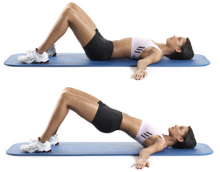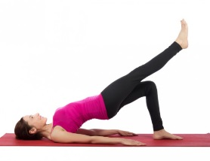Bridge Ups (Hip Ups) | 3 | 10 | -The bum should start off the floor about an inch, it should not be set back down until the entire set is complete.  -Lift and squeeze the glutes, the body should be in a straight line from shoulders to knees.  -Try single leg for more challenge
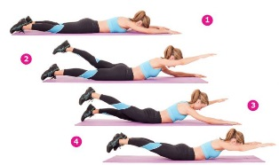  Supermans | 3 | 10 | -This works the low back. Ensure that you squeeze the glutes and keep the core tight.  -You can alternate opposite arms and legs or extend all four limbs.  To increase challenge, increase hold time.
Russian Twists | 3 | 10 | -Sit up tall, Chest up, shoulders down and back. The weight should be close to your middle.  -The feet can stay on the ground to make this exercise easier.  -If the low back starts to ache, stop the exercise.
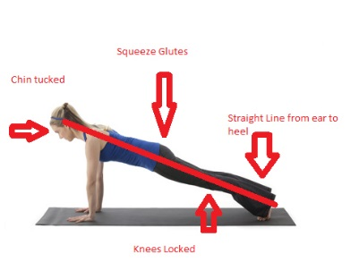  Plank | 3 | Hold Until Failure | -Hands for less than a minute, anything over a minute should be done on forearms.  -Keep the shoulders stacked over the elbows.  -Feet together, quads and pelvis engaged.  -Neutral spine, keep the eyes looking straight down or ahead 3-4 inches. Slightly tuck the pelvis.  -If the low back starts to ache, stop the exercise.
What is TRX?
TRX Suspension Training was created in the Navy Seals. The founder of TRX, Randy Hetrick, created the system so that he and his team could stay in shape while on missions. The TRX originally started out as a collection of parachute webbing that was hand stitched together. The TRX system is based off of working with one’s own body weight. Hetrick and his teammates created a large array of exercises that were both functional and effective for their training purposes. This invention eliminated the need for bulky weights and equipment. The now popular training system only weighs 2lbs and can be used almost anywhere.
Part of the TRX claim to fame is that it combines functional movements with flexibility, balance and core stability. The TRX slogan is “All core, all the time.” This particular training system can be used with almost any fitness level and age group. It can be used to rehabilitate injuries or to get in an intense strength workout.
TRX uses the idea of suspension training which in this case refers to a unique collection of bodyweight exercises, cues and program principles. TRX suspension differs from other suspended training systems in that the body, feet or hands are supported by a single anchor point, while the opposite end is supported by the ground. The single point attachment provides a combination of support and mobility, this allows the individual to train strength, endurance, balance, coordination, flexibility, power, and core stability. It also lets you train in more than one plane of motion. Many traditional strength exercises only have you train in one plan of motion, where the TRX allows you to train the sagittal, transverse and frontal plane.

Guidelines for Using the TRX Suspension Trainer:
- Posture: Posture is the number one thing to remember when using the TRX. We have discussed proper posture previously. It doesn’t change much when related to the TRX. Here are a few things to keep in mind when it comes to TRX and posture;
- Keep your eyes up, look toward the anchor of the TRX straps
- Engage your core.
- Keep a neutral spine.
- Shoulders down, chest up.
- Your body should be rigid, picture yourself as a stiff board.
- Keep straps tight: The TRX straps should never hang or have slack while doing an exercise. It is okay to maintain a loose grip on the handles, but the straps should always be taut.
- Vector Resistance Principle: Also known as the angle of your body. When standing upright, your body supports 100% of your weight. As your body angle steepens, your center of gravity moves outside your base of support and weight transitions onto the TRX. This adds resistance to an exercise. The steeper your body angle the greater the resistance for the exercise.
- Pendulum Principle: This principle is applied to all floor work using the TRX. The TRX naturally hangs straight down in what is referred to as “neutral position.” You can assist yourself or add resistance to an exercise by changing the starting position relative to the neutral position. Positioning the body to the far side of neutral, so your head is closer to the anchor, will make the exercise easier. However moving your head and body away from the anchor will cause the exercise to become more challenging.
- Stability Principle a.k.a. Foot Position: The position your feet can greatly change the challenge level of an exercise. There are four foot positions used with the TRX trainer;
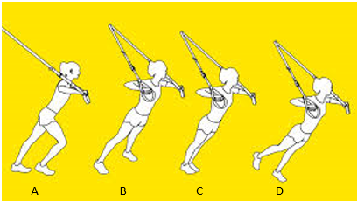
- Offset Foot Position: this is the simplest form. It allows the individual to offset the body weight on the muscle being worked, and therefore decrease difficulty.
- Wide Foot Position: This is slightly more challenging, however it creates a greater base of support, therefore making the movements more stable.
- Narrow Foot Position: More challenging still, this foot position narrows your base of support.
- Single Foot Position: the most challenging position as you’re only supported by one foot. Your core has to work harder to maintain stability. Also a consideration is to alternate the single leg you are standing on so you maintain muscle balance in each leg.

TRX Workout:
Remember TRX is “All Core, All the Time,” keep the core engaged in every exercise. There will be some exercises where you feel it more than others but really focus on keeping it strong for all exercises. This workout should be started with a 5-10 minute cardio warm up. From there complete 10 of each exercise, 3 times through. Rest and drink after each round.
Exercise | Sets | Reps | Cues
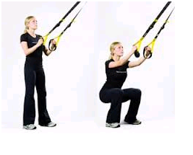  TRX Squats | 3 | 10 | - Hands start at chest, elbows bent.  - Keeping weight in heels, sit back as if sitting into a chair.  - Use the quads and glutes to return to standing.
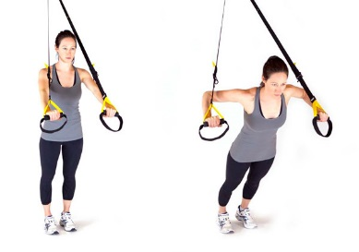  TRX Chest Press | 3 | 10 | - Facing away from the anchor, the straps should run over top your arms.  -Start with arms outstretched, hands even with armpits.  -Bend the elbows, down and back, lowering the chest between your hands.
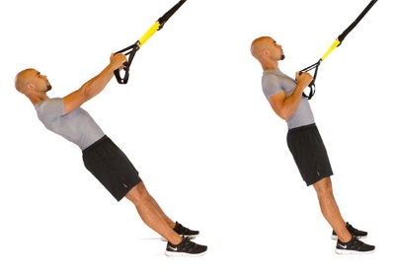  TRX Row | 3 | 10 | -Facing the anchor, arms outstretched in front of you, hands level with arm pits.  -Posture, shoulders down and back, chest up.  -Pulling with the back muscles, pull your body toward your hands. Squeeze your shoulder blades together.  -Keep a rigid plank position with body.
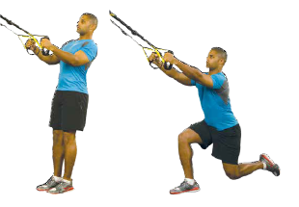  TRX Step Back Lunge | 3 | 10 | -Start with hands at chest.  -Step back with one leg, your knees should both be at 90 degree angles. Knees behind toes.  -Do not lean forward, your upper body should be tall.  - Drive through the heel of the front leg, squeeze the glutes and return to standing.
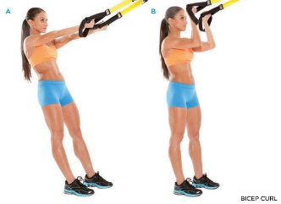  TRX Bicep Curl | 3 | 10 | -Start with arms extended in front of you with hands level with arm pits. Palms up. Posture- keep the shoulders down, chest up.  -Bend at the elbow and curl the hands to the head. Do not drop the elbows below the armpits.
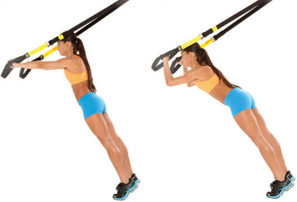  TRX Tricep Extension | 3 | 10 | -Start facing away from the anchor.  -Arms outstretched in front of you, hands level with armpits.  -Bend the elbows, and bring the head to the back of the hands.  -The elbows should not drop below armpits or flair outside of the shoulders.
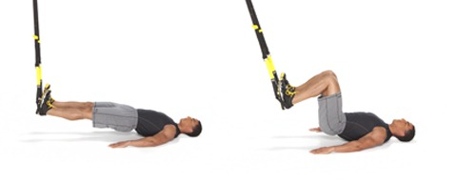  TRX Hamstring Curl | 3 | 10 | -Lying on the floor, place your heels in the foot loops of the TRX.  -With leg straight, engage the core and lift the bum off the ground at least 1 inch.  -Pull the heels to the bum, by bending the knees. -Return to straight legs. Do not let the bum drop to the ground.
TRX Plank Tucks | 3 | 10 | -Place the toes in the foot straps.  -Start by getting into a strong plank position. Do not let the low back sag.  -Once the plank is strong, pull the knees into the chest.  -Return to the plank. Ensure the plank is strong every time.

Flexibility – Range of Motion - Stretching

What is Flexibility?
Flexibility is commonly described as the range of motion, or movement, around a particular joint or set of joints. Or in layman’s terms, how far we can reach, bend or turn. When improving flexibility is the goal, the muscles and their fascia (sheath) should be the major focus of flexibility training. While bones, joints, ligaments, tendons and skin do contribute to overall flexibility, we have limited control over these factors.

Two Types of Flexibility:
Within the broader definition of flexibility there exists two distinct types of flexibility: Static and Dynamic. The term static flexibility refers to an individual’s absolute range of motion that can be achieved without movement. In other words, how far we can reach, bend or turn and then hold that position. While the term dynamic flexibility refers to an individual’s absolute range of motion that can be achieved with movement. In other words, how far we can reach, bend or turn by using velocity to achieve maximum range of motion. Static flexibility is sometimes referred to as passive flexibility, and dynamic flexibility is sometimes referred to as ballistic or functional flexibility.

Range of Motion (ROM):
Range of motion (ROM), or range of movement, is so intimately related to flexibility that the terms are often considered having the same meaning. That is, they all describe the extent to which a joint can go in its established spectrum of movements.
A joint’s normal range of motion is determined by what that joint does and how far the bones that comprise it can move. So, range of motion also measures the current amount of motion around a joint as determined by the condition of the bones and the soft tissue surrounding the joint that hold it together.

What is Stretching?
Stretching, as it relates to physical health and fitness, is the process of placing particular parts of the body into a position that will lengthen, or elongate, the muscles and associated soft tissues. Upon undertaking a regular stretching program a number of changes begin to occur within the body and specifically within the muscles themselves. Other tissues that begin to adapt to the stretching process include the fascia, tendons, ligaments, skin and scar tissue.

Two Types of Stretching:
Although there are many different ways to perform a stretching exercise, they can all be grouped into one of two categories: Static or Dynamic.
The term static stretches refers to stretching exercises that are performed without movement. In other words, the individual gets into the stretch position and holds the stretch for a specific amount of time. While the term dynamic stretches refers to stretching exercises that are performed with movement. In other words, the individual uses a swinging or bouncing movement to extend their range of motion and flexibility.

Many Different Ways to Stretch:
Just as there are many different ways to strength train, there are also many different ways to perform stretching exercises. However, it is important to note that although there are many different ways to stretch, no one way, or no one type of stretching is better than another. Each type has its own advantages and disadvantages, and the key to getting the most out of stretching lies in being able to match the right type of stretching to the purpose, or goal you are trying to achieve.
For example; PNF and passive stretching are great for creating permanent improvements in flexibility, but they are not very useful for warming up or preparing the body for activity. Dynamic stretching, on the other hand, is great for warming up but can be dangerous if used in the initial stages of injury rehabilitation.

Listed below are five different types of static stretching exercises.
- Static Stretching: Static stretching is performed by placing the body into a position whereby the muscle (or group of muscles) to be stretched is under tension. Both the antagonist, or opposing muscle group and the agonist, or muscles to be stretched are relaxed. Then slowly and cautiously the body is moved to increase the tension of the muscle (or group of muscles) being stretched. At this point the position is held or maintained to allow the muscles to lengthen. A minimum hold time of about 20 seconds is required for the muscles to relax and start to lengthen, while diminishing returns are experienced after 45 to 60 seconds. Static stretching is a very safe and effective form of stretching with a limited threat of injury. It is a good choice for beginners and sedentary individuals.
- Passive (or Assisted) Stretching: This form of stretching is very similar to static stretching; however another person or apparatus is used to help further stretch the muscles. Due to the greater force applied to the muscles, this form of stretching is slightly more hazardous. Therefore it is very important that any apparatus used is both solid and stable. When using a partner it is imperative that no jerky or bouncing force is applied to the stretched muscle. So, choose a partner carefully, the partner is responsible for the safety of the muscles and joints while performing the stretching exercises. Passive stretching is useful in helping to attain a greater range of movement, but carries with it a slightly higher risk of injury. It can also be used effectively as part of a rehabilitation program or as part of a cool down.
- Active Stretching: Active stretching is performed without any aid or assistance from an external force. This form of stretching involves using only the strength of the opposing muscles (antagonist) to generate a stretch within the targeted muscle group (agonist). The contraction of the opposing muscles helps to relax the stretched muscles. A classic example of an active stretch is one where an individual raises one leg straight out in front as high as possible and then maintains that position without any assistance from a partner or object. Active stretching is useful as a rehabilitation tool and a very effective form of conditioning before moving onto dynamic stretching exercises. This type of stretching exercise is usually quite difficult to hold and maintain for long periods of time and therefore the stretch position is usually only held for 10 to 15 seconds.
- PNF Stretching: PNF stretching, or Proprioceptive Neuromuscular Facilitation, is a more advanced form of flexibility training that involves both the stretching and contracting of the muscle group being targeted. PNF stretching was originally developed as a form of rehabilitation and for that function it is very effective. It is also excellent for targeting specific muscle groups, and as well as increasing flexibility, (and range of movement) it also improves muscular strength. There are many different variations of the PNF stretching principle and sometimes it is referred to as Contract-Relax stretching or Hold-Relax stretching. Post Isometric Relaxation (PIR) is another variation of the PNF technique. The area to be stretched is positioned so that the muscle (or muscle group) is under tension. The individual then contracts the stretched muscle group for 5 – 6 seconds while a partner (or immoveable object) applies sufficient resistance to inhibit movement. The effort of contraction should be relevant to the level of conditioning. The contracted muscle group is then relaxed and a controlled stretch is applied for about 30 seconds. The athlete is then allowed 15 to 30 seconds to recover and the process is repeated 2 – 4 times.
- Isometric Stretching: Isometric stretching is a form of passive stretching similar to PNF stretching, but the contractions are held for a longer period of time. Isometric stretching places high demands on the stretched muscles and is not recommended for children or adolescents who are still growing. Other recommendations include allowing at least 48 hours rest between isometric stretching sessions and performing only one isometric stretching exercise per muscle group in a session. To perform an isometric stretch; assume the position of the passive stretch and then contract the stretched muscle for 10 to 15 seconds. Be sure that all movement of the limb is restricted. Then relax the muscle for at least 20 seconds. This procedure should be repeated two to five times.

Listed below are four different types of dynamic stretching exercises:
- Ballistic Stretching: Ballistic stretching is an outdated form of stretching that uses momentum generated by rapid swinging, bouncing and rebounding movements to force a body part past its normal range of movement. The risks associated with ballistic stretching far outweigh the gains, especially when better gains can be achieved by using other forms of stretching like dynamic stretching and PNF stretching. Other than potential injury, the main disadvantage of ballistic stretching is that it fails to allow the stretched muscle time to adapt to the stretched position and instead may cause the muscles to tighten up by repeatedly triggering the stretch reflex (or myotatic reflex).
- Dynamic Stretching: Unlike ballistic stretching, dynamic stretching uses a controlled, soft bounce or swinging motion to move a particular body part to the limit of its range of movement. The force of the bounce or swing is gradually increased but should never become radical or uncontrolled. Do not confuse dynamic stretching with ballistic stretching. Dynamic stretching is slow, gentle and very purposeful. At no time during dynamic stretching should a body part be forced past the joints normal range of movement. Ballistic stretching, on the other hand, is much more aggressive and its very purpose is to force the body part beyond the limit of its normal range of movement.
- Active Isolated (AI) Stretching: Active isolated (AI) stretching is a new form of stretching developed by Aaron L. Mattes. AI stretching is sometimes referred to as the Mattes Method. It works by contracting the antagonist, or opposing muscle group, which forces the stretched muscle group to relax. While AI stretching certainly has some benefits (mainly for the professional or well-conditioned athlete), it also has a lot of unsubstantiated claims. One such claim is that AI stretching does not engage the stretch reflex because the stretch is only held for 2 seconds or less. This is nonsense and defies basic muscle physiology. The stretch reflex in the calf muscle for example is triggered within 3 hundredths of a second, so any claim that AI stretching can somehow bypass or outsmart the stretch reflex is nothing more than fantasy.
- Resistance Stretching and Loaded Stretching: Resistance stretching and loaded stretching are a form of dynamic stretching that both contract and lengthen a muscle at the same time. They work by stretching a muscle group through its entire range of motion while under contraction. For this reason, both resistance stretching and loaded stretching are as much about strengthening a muscle group as they are about stretching it. Like AI stretching above, resistance stretching and loaded stretching do have their benefits. Five time Olympic swimmer, Dara Torres credits a portion of her swimming success to the use of resistance stretching. However, these forms of stretching place high demands on the musculo-skeletal system and are therefore only recommended for professional or well-conditioned athletes.

Improve your Flexibility:
A regular flexibility training program, consistently employed over the long term, is the only way to permanently improve your flexibility and range of motion. Maintaining range of motion through stretching techniques effectively and safely help keep and improves your full body mobility and freedom of movement so you can...
•Get rid of injury, soreness and pain;
•Recovery quickly from annoying sports injury; and
•Do away with stiff, tight muscles and joints for good.

Stretching Routine (pictures below):
- On back
  - knees to chest – rock – low back
  - cross one leg/then other – hip/back
  - one knee to chest other leg straight/other - hip
  - bring one leg across body as one straight/other – back/glute
- Cross legged
  - reach to left/right and lean/swing around – back/shoulder
  - chicken stretch – back/shoulder/pec
- Front
  - cat/cow – spine
  - wrist
  - bird/dog – core/body
  - cobra – 2 times in sequence through forward fold/back
  - downward dog – shoulder/pedal feet for calve stretch
  - plank - core
  - walk into forward fold
- Seated
  - seated foot/toe stretch/knee/ankle
  - transition to butterfly-groin/adductor
  - proposal hip/quad stretch
  - pigeon stretch – hip/glute
- Stand
  - tall bend side to side )grab wrist; transition to straight arms behind pec stretch
  - wide legs bent over with and without arms locked behind back
  - bring feet in – squat – open knees – on toes if hips to tight to go down on heels
  - knees frog stretch – groin/adductor/hips
  - t-spine w/straight leg
  - strider stretch with rotations – hips/legs/t-spine rotation
- Seated
  - alternate hamstring stretch – nose to knee
  - feet together – grab toes and pull – chest to thighs
  - stack knees – alternate and lean – glute/hips
  - rotation/twist stretch – spine/glute
- Back
  - lying hip rotation – hip rotators
  - box bridge (wrestler twist) - core
  - bridge (wheel bridge) - core
  - legs up and over - core
  - lower legs 10 seconds – core
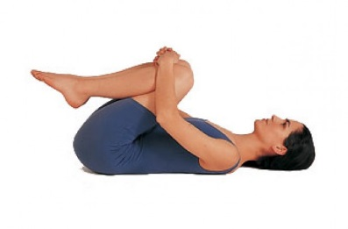  Knees to chest – knee closed and open | 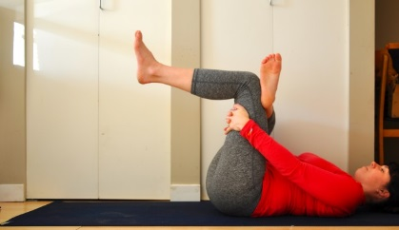  Lying cross legged stretch – both sides | 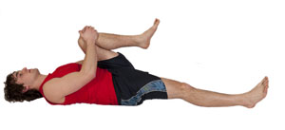  Single knee to chest – both sides
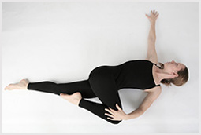  Lying twist stretch – both sides | Cross legged side-to-side stretch | Shoulder-chest stretch-we did ours seated
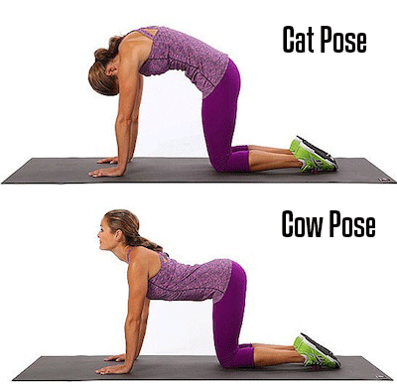 | 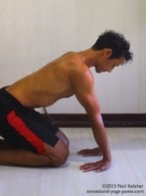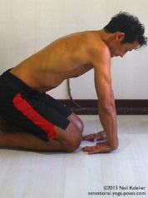  Kneeling wrist stretches | 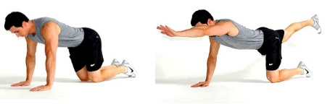  Bird dog
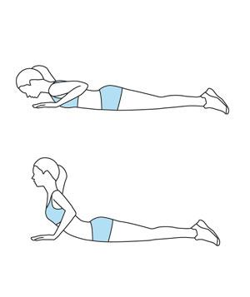  Cobra – use back not arms | Downward dog – legs can be straight and pedal feet for calve stretch | Plank
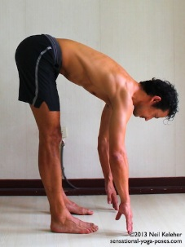  Forward fold | 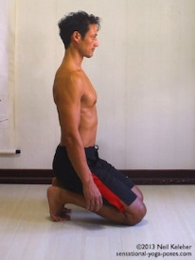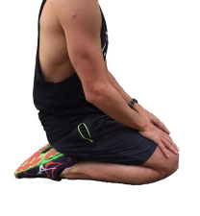  Ankle/toe/knee stretch:  One last version – sit bum inside feet – knees together, bum on floor with heels touching side of bum | Groin Butterfly Stretch
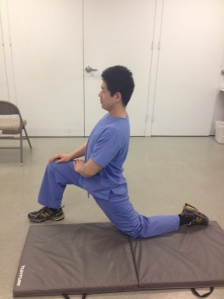  Proposal - hip/quad stretch  Intensify stretch by grabbing ankle and lean forward | 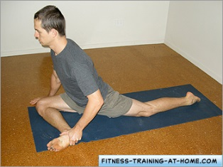  Pigeon hip/glute stretch - Goal for pigeon | Modified pigeon
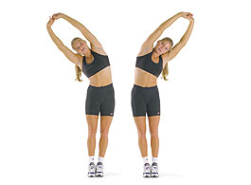  Side bend – grab wrist – add reverse shoulder/pec straight arm stretch | 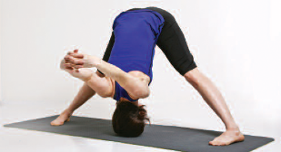  Wide leg bent over – with/without shoulder stretch | 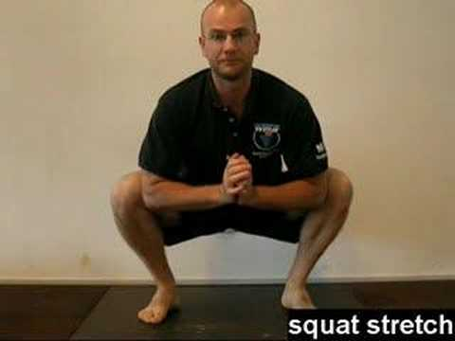  Squat Stretch
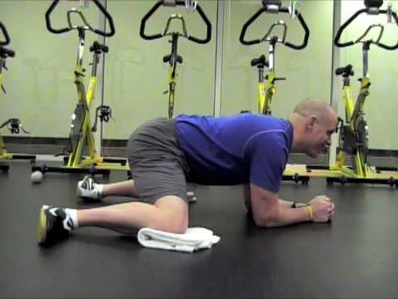  Frog Stretch | 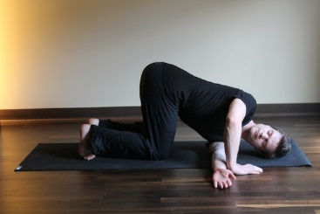  Twisting t-spine stretch | Strider stretch w/rotation both ways
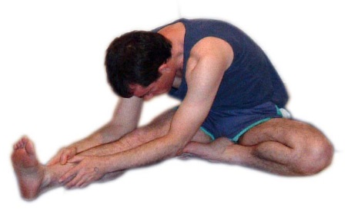  Hamstring | Hamstring/calve/back | 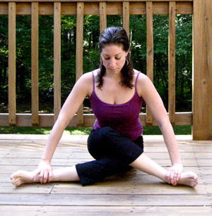  Stacking Knees glute stretch
Rotating spine/glute stretch | Hip rotator | 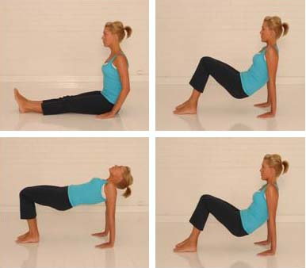  Box Bridge
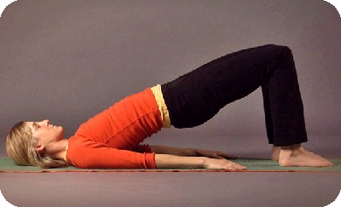  Bridge – basic | 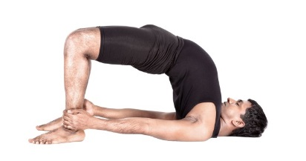  Bridge - advanced | 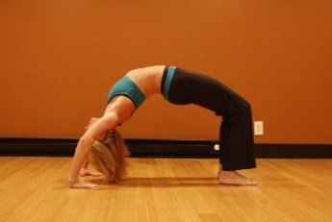  Bridge- Wheel
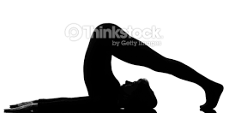  Leg overs - Neck, hamstring, shoulders, core | 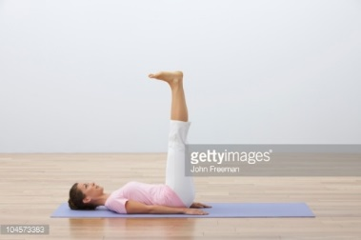  Legs up - Hamstrings core | Leg lowering – core

