WHAT WE DO:
Burman University Writing Centre

Information Sheet for Students

The Burman University Writing Centre offers writing support services to all Burman students in all subject areas. Our goal is to help students become more confident, self-directed, and informed writers so that they can achieve greater academic and professional success. The Writing Centre offers one-on-one tutoring, workshops, and a variety of helpful support materials.

WHAT WE CAN PROVIDE:
- One-on-one tutoring
- Writing Workshops
- Support Materials
- Citation Manuals

HOW WE CAN HELP YOU:
- We can help you clarify your writing goals and assignments
- We can help you understand and develop your writing process
- We can help you write strong thesis statements and topic sentences
- We can offer strategies for organizing paragraphs and essays
- We can help you use reference materials
- We can help you diagnose writing problems
- We can help you edit and proofread your work
- We can answer questions about grammar and mechanics
- We can answer questions about formatting and citation

WAYS TO CONNECT WITH OUR SERVICES:
Drop in to our location in the library!

Make an appointment!
You can make an appointment online; go to https://www.facebook.com/BurmanWritingCentre/events and click on the “Book Now” link or email us at WritingCentre@burmanu.ca.

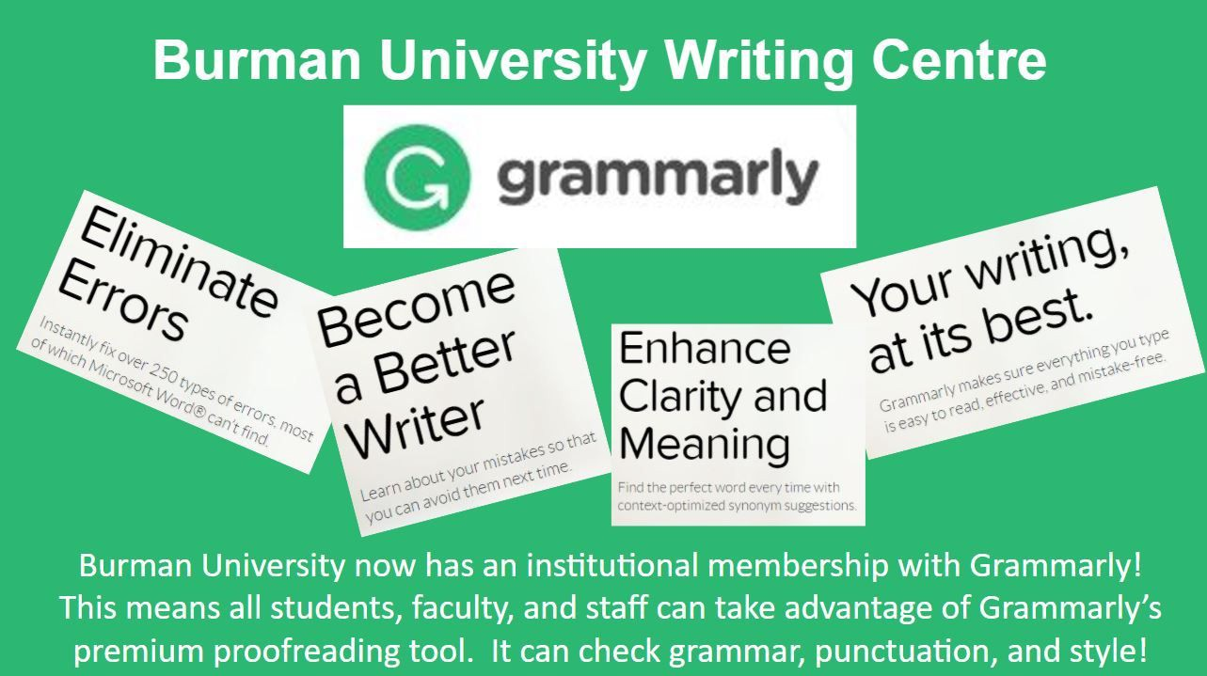
And the Writing Centre hopes that you will take advantage of the new service we have to offer, Grammarly! It will help you with your proofreading and grammar skills!

To create a free account, go to https://www.grammarly.com/edu/signup and create an account using your Burman email address. If you have any questions on how it works, or if you have any problems creating an account, please contact the Writing Centre!

Thank you for taking the time to learn more about our services.
We look forward to working with you!

